AICTE | IBM SkillsBuild
Data Analytics with AI Internship 2026
PROJECT REPORT
Student Performance Analytics & Prediction

Prepared by: Harshal Jadhav

Dataset: Student Performance Factors
Target Variable: Exam_Score
Source: Kaggle — Lai Nguyen

1. Abstract
This project develops an end-to-end student performance analytics and machine-learning workflow using the Student Performance Factors dataset. The analysis converts student-related data into executive KPIs, descriptive patterns, driver analysis, risk indicators and predictive results.
The executed notebook uses the external StudentPerformanceFactors.csv dataset containing 6,607 records and 20 variables. A Random Forest regression model is trained to predict Exam_Score, while permutation importance is used to identify influential original features.

2. Introduction
Educational performance can be studied using measurable factors such as attendance, study hours, previous scores, tutoring, motivation, access to resources and other student characteristics. This project demonstrates how these variables can be analyzed using Python and machine learning to generate structured, interpretable insights.

3. Problem Statement
To analyze student performance factors, identify descriptive relationships and risk groups, and develop a machine-learning model that predicts examination scores from available student factors.

4. Objectives
- Load and validate the Student Performance Factors dataset.
- Identify missing values, duplicates and data types.
- Calculate executive KPIs for student performance.
- Explore relationships between academic and lifestyle variables and Exam_Score.
- Compare selected categorical groups using descriptive statistics.
- Create a transparent student-risk screening framework.
- Train and evaluate a Random Forest regression model.
- Identify important features using permutation importance.
- Translate analytical results into practical academic-support actions.

5. Dataset Description
The project uses the Student Performance Factors dataset published on Kaggle by Lai Nguyen. The executed notebook confirms a dataset shape of 6,607 rows and 20 columns.
Category | Variables
Academic | Hours_Studied, Attendance, Previous_Scores, Tutoring_Sessions, Exam_Score
Lifestyle | Sleep_Hours, Physical_Activity
Motivation / Support | Motivation_Level, Parental_Involvement, Access_to_Resources
Family | Family_Income, Parental_Education_Level
School | Teacher_Quality, School_Type, Distance_from_Home
Social / Technology | Peer_Influence, Internet_Access, Extracurricular_Activities
Student Characteristics | Learning_Disabilities, Gender

Dataset source: https://www.kaggle.com/datasets/lainguyn123/student-performance-factors

6. Technologies Used
Technology | Purpose
Python | Programming and analysis
Pandas | Data loading, cleaning and tabular analysis
NumPy | Numerical operations
Matplotlib | Visualization
Scikit-learn | Preprocessing, Random Forest and evaluation
Jupyter Notebook | Interactive project execution and documentation

7. Project Workflow
Data Loading → Data Quality → Cleaning → KPI Analysis → Exploratory Data Analysis → Driver Analysis → Risk Analysis → Machine Learning → Feature Importance → BI Summary.
The project follows the analytics hierarchy: KPI → Pattern → Driver → Risk/Opportunity → Action.

8. Data Quality and Preparation
The executed notebook loaded the external dataset successfully. No duplicate rows were found. Missing values were identified in Parental_Education_Level, Teacher_Quality and Distance_from_Home.
Variable | Missing Values
Parental_Education_Level | 90
Teacher_Quality | 78
Distance_from_Home | 67

For machine learning, numerical variables are handled with median imputation and categorical variables with most-frequent imputation followed by one-hot encoding inside the preprocessing pipeline.

9. Executive KPI Analysis
KPI | Actual Result
Total Students | 6,607
Average Exam Score | 67.24
Pass Rate (>= 50) | 100.00%
Average Attendance | 79.98%
Average Study Hours | 19.98

10. Exploratory Data Analysis
The executed notebook visualizes the exam-score distribution and examines the relationship between study hours and exam score. These visualizations are descriptive and do not establish causation.
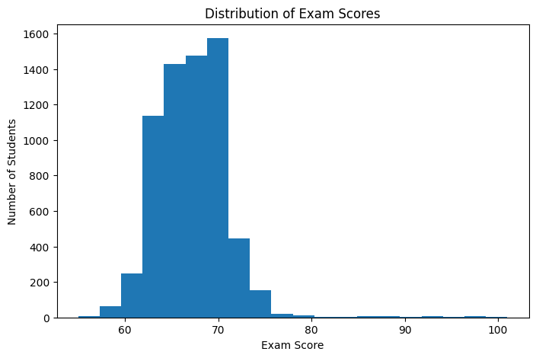
Figure 1. Distribution / Performance Visualization
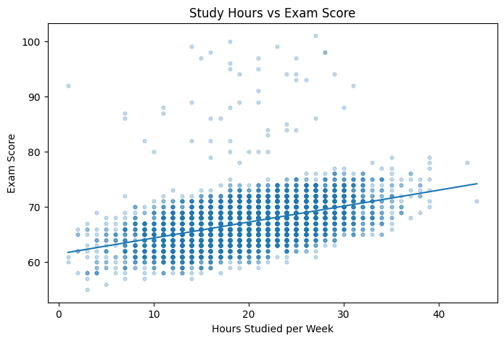
Figure 2. Study Hours vs Exam Score

11. Driver Analysis
The executed analysis calculated correlations between numeric variables and Exam_Score. Attendance showed the largest positive numeric correlation, followed by Hours_Studied, Previous_Scores and Tutoring_Sessions.
Variable | Correlation with Exam_Score
Attendance | 0.581072
Hours_Studied | 0.445455
Previous_Scores | 0.175079
Tutoring_Sessions | 0.156525
Physical_Activity | 0.027824
Sleep_Hours | -0.017022

By Motivation_Level, the observed mean Exam_Score values were: High = 67.70, Medium = 67.33 and Low = 66.75.
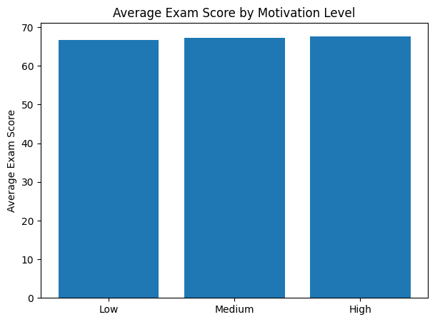
Figure 3. Correlation Visualization

12. Student Risk Analysis
The notebook uses a project-defined screening framework based on Exam_Score and Attendance. The risk labels are analytical indicators for demonstration and are not official academic classifications.
Risk Level | Students | Percentage
Low | 3,896 | 58.97%
Medium | 2,648 | 40.08%
High | 63 | 0.95%
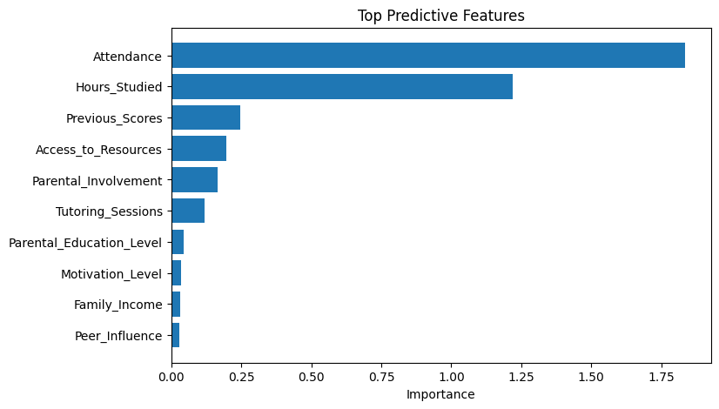
Figure 4. Risk Distribution

13. Machine Learning Model
A Random Forest Regressor was used to predict Exam_Score. The model uses an 80/20 train-test split, 250 trees, random_state = 42 and min_samples_leaf = 2. Numeric and categorical preprocessing is performed inside a Scikit-learn pipeline.
Component | Configuration
Algorithm | Random Forest Regressor
Trees | 250
Minimum Samples per Leaf | 2
Random State | 42
Train/Test Split | 80% / 20%
Target | Exam_Score

14. Model Evaluation
Metric | Actual Result
MAE | 1.0537
MSE | 4.4819
R² | 0.6829

The model achieved a test MAE of 1.0537, meaning the average absolute prediction error was approximately 1.05 exam-score points on the held-out test set. R² was 0.6829 for this executed run.

15. Feature Importance
Permutation importance was calculated on the held-out test set. The top features in the executed notebook were Attendance, Hours_Studied, Previous_Scores, Access_to_Resources and Parental_Involvement.
Feature | Permutation Importance
Attendance | 1.835600
Hours_Studied | 1.219833
Previous_Scores | 0.246796
Access_to_Resources | 0.196845
Parental_Involvement | 0.164495
Tutoring_Sessions | 0.119547
Parental_Education_Level | 0.043458
Motivation_Level | 0.034886
Family_Income | 0.030740
Peer_Influence | 0.029132

16. Business Intelligence Summary

Facts
- The dataset contains 6,607 student records.
- Average Exam_Score is 67.24.
- Average attendance is 79.98%.
- Attendance and Hours_Studied show the strongest positive numeric relationships with Exam_Score in this analysis.

Insights
- Students with stronger previous scores tend to have higher current exam scores in the observed data.
- Higher study hours are positively associated with exam score.
- Attendance has a comparatively strong positive association with exam score.

Risks and Opportunities
- The risk framework identifies a small high-risk group for additional review.
- Attendance and study patterns provide measurable areas for academic monitoring.
- Tutoring, resource access and other categorical factors can be reviewed at group level.

17. Recommended Actions
- Monitor attendance and academic performance together for early academic support.
- Use study-time and previous-performance patterns when planning support activities.
- Review tutoring and resource-access patterns for students requiring additional assistance.
- Treat model predictions as decision-support information rather than automatic student classifications.

18. Limitations and Responsible Use
- The dataset is a public educational dataset and may not represent every student population.
- Correlation does not establish causation.
- Risk thresholds in this project are project-defined analytical rules.
- The model is a demonstration model and should not be used as the sole basis for high-stakes decisions.
- Model results can change with the dataset version, train/test split and model configuration.

19. Future Scope
- Develop an interactive Streamlit or Power BI dashboard.
- Compare multiple regression algorithms.
- Add longitudinal student records for time-based analysis.
- Use explainable-AI methods such as SHAP for individual predictions.
- Validate the workflow on institution-specific data before operational use.

20. Conclusion
The project demonstrates a complete data analytics and AI workflow for student performance. The executed analysis combines data-quality checks, KPIs, exploratory analysis, driver analysis, risk screening, Random Forest prediction and feature importance. The results provide a structured basis for academic monitoring and further dashboard development while recognizing the limitations of descriptive associations and predictive modeling.

21. Project Deliverables
File | Purpose
Harshal_StudentPerformance_Analytics.ipynb | Complete executed analytics and ML notebook
requirements.txt | Python dependencies
Harshal_StudentPerformance_Report.docx | Project documentation
README.md | Project overview, dataset and setup instructions

22. References
Kaggle — Student Performance Factors, Lai Nguyen.
https://www.kaggle.com/datasets/lainguyn123/student-performance-factors
Scikit-learn documentation: https://scikit-learn.org/

